**Excel Assignment 1**

1. What is Excel? Why do we use Excel?

Excel is a spreadsheet program from Microsoft and a component of its Office product group for business applications. Microsoft Excel enables users to format, organize and calculate data in a spreadsheet.

By organizing data using software like Excel, data analysts and other users can make information easier to view as data is added or changed. Excel contains a large number of boxes called cells that are ordered in rows and columns. Data is placed in these cells.

Excel is most commonly used in business settings. For example, it is used in business analysis, [human resource management](https://www.techtarget.com/searchhrsoftware/definition/human-resource-management-HRM), operations management and performance reporting. Excel uses a large collection of cells formatted to organize and manipulate data and solve mathematical functions. Users can arrange data in the spreadsheet using graphing tools, [pivot tables](https://searchsqlserver.techtarget.com/definition/pivot-table) and formulas. The spreadsheet application also has a macro programming language called Visual Basic for Applications.

1. List all the versions of Microsoft excel. Compare excel software provided from multiple vendors.

[Excel 365](https://thesmartmethod.com/excel-versions-explained/#365)  
[Excel 2021](https://thesmartmethod.com/excel-versions-explained/#2021)  
[Excel 2019](https://thesmartmethod.com/excel-versions-explained/#2019)  
[Excel 2016 and 365](https://thesmartmethod.com/excel-versions-explained/#2016)  
[Excel 2013 (Windows)](https://thesmartmethod.com/excel-versions-explained/#2013)  
[Excel 2011 (Mac)](https://thesmartmethod.com/excel-versions-explained/#2011)  
[Excel 2010 (Windows)](https://thesmartmethod.com/excel-versions-explained/#2010)  
[Excel 2008 (Mac)](https://thesmartmethod.com/excel-versions-explained/#2008)  
[Excel 2007 (Windows)](https://thesmartmethod.com/excel-versions-explained/#2007)  
[Excel 2004 (Mac)](https://thesmartmethod.com/excel-versions-explained/#2004)  
[Excel 2003 (Windows)](https://thesmartmethod.com/excel-versions-explained/#2003)  
[Older Windows versions (2002, 2000, 97, 95, 4.0, 3.0, 2.0)](https://thesmartmethod.com/excel-versions-explained/#olderwindows)  
[Older Mac versions (2001, 2000, 98, 5, 4, 3, 2, 1)](https://thesmartmethod.com/excel-versions-explained/#oldermac)  
[OS/2 Versions (2.2, 2.3, 3)](https://thesmartmethod.com/excel-versions-explained/#os2)

1. How to create bar charts in excel, demonstrated with practical examples.

Click Insert > Insert Column or Bar Chart icon, and select a column chart option of your choice

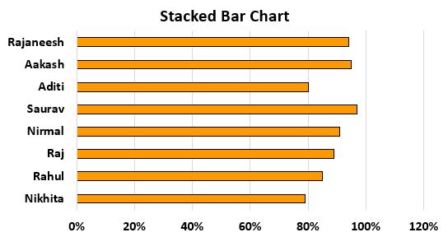

1. Create an analytics dashboard in python and present your findings.

import dash

import dash_core_components as dcc

import dash_html_components as html

import pandas as pd

data = pd.read_csv("avocado.csv")

data = data.query("type == 'conventional' and region == 'Albany'")

data["Date"] = pd.to_datetime(data["Date"], format="%Y-%m-%d")

data.sort_values("Date", inplace=True)

app = dash.Dash(__name__)

1. How to connect Excel with the databases.

To connect Excel to a database in SQL Database, open Excel and then create a new workbook or open an existing Excel workbook. In the menu bar at the top of the page, select the Data tab, select Get Data, select From Azure, and then select From Azure SQL Database.